**OPERATING**

**SYSTEM**

**LAB – 4**

**Compilation of C programs.**

**Using Ubuntu App**

**Submitted by: ~**

**Ayushi Kumari**

**RA1911003010865.**

1. Print output as “Hello World” using C language in Ubuntu Terminal.

Input: -

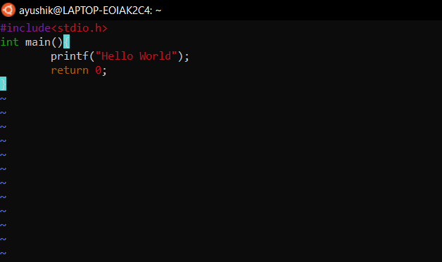

Output: -

Command used to compile = gcc filename.c

Filename is helloworld

Displayed Output is Hello World

Command used to print output = ./a.out

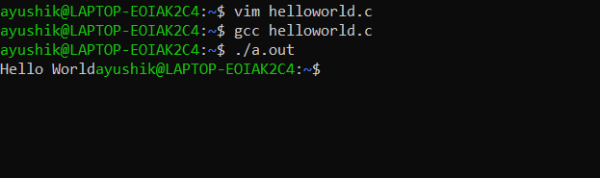

1. Compilation of Sum of two numbers using C language in Ubuntu Terminal.

Input: -

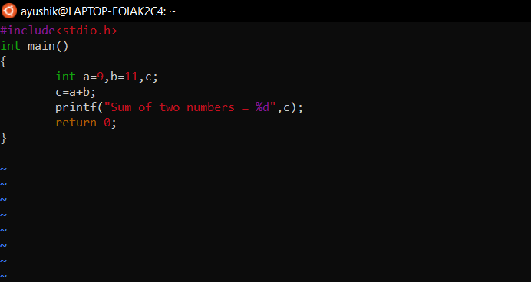

Output: -

Output: -

Command used to compile = gcc filename.c

Filename is sumn

Displayed Output is Sum of two numbers = 20

Command used to print output = ./a.out

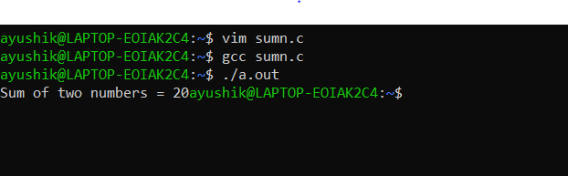

1. Compilation of Difference of two numbers using C language in Ubuntu Terminal.

Input: -

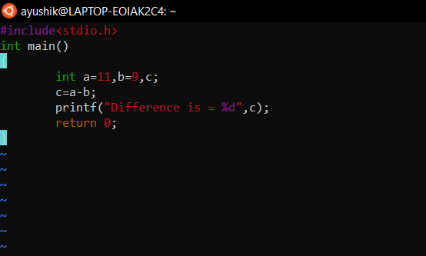

Output: -

Command used to compile = gcc filename.c

Filename is subtract.

Displayed Output is Difference is 2

Command used to print output = ./a.out

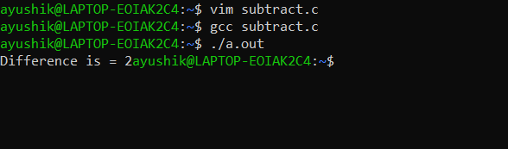

1. Compilation of Multiplication of two numbers using C language in Ubuntu Terminal.

Input: -

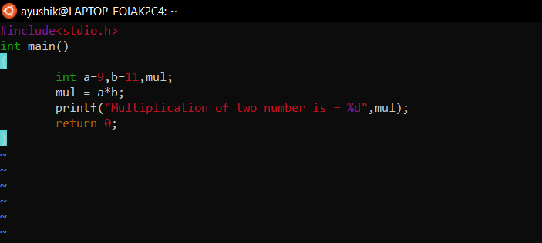

Output: -

Command used to compile = gcc filename.c

Filename is multiplication

Displayed Output is Multiplication of two number is = 99

Command used to print output = ./a.out

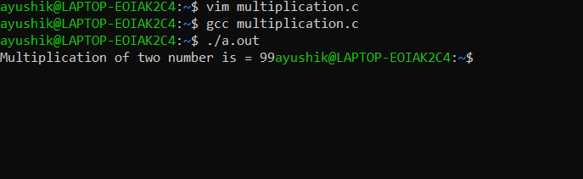

1. Compilation of Intro of yourself using C language in Ubuntu Terminal.

Input: -

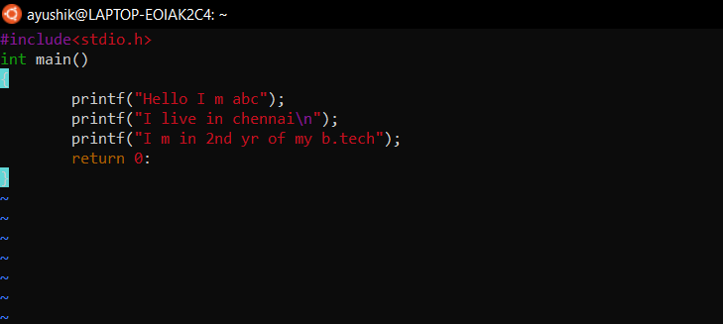

Output: -

Command used to compile = gcc filename.c

Filename is intro

Displayed Output is Hello I m abcI live in chennai

I m in 2nd yr of my b.tech

Command used to print output = ./a.out

